- Ensure the MongoDB collection git repo is up-to-date

<$Scr_Ps::0>cd ~/git/ansible_collections/community/mongodb
git pull

- Create a new branch

git checkout -b mybugfix

- Fix your bug

// whatever

- Commit your changes

git add path/to/changed/files
git commit -m "My bug fix"
git push --set-upstream origin mybugfix

- Create the pull request

<!$Scr_Ps::0>You should see a url in the in the output of the last command. Paste this url into a web browser to begin creating your PR.
<$Scr_Ps::0>
https://github.com/ansible-collections/community.mongodb/pull/new/mybugfix

<!$Scr_Ps::0>Fill out as much information as possible and click the „Create pull request“ button when finished.

- Ensure continuous integration tests pass. Normally, for the PR to be accepted, all the tests should pass. Make any needed modifications and the tests will run again.

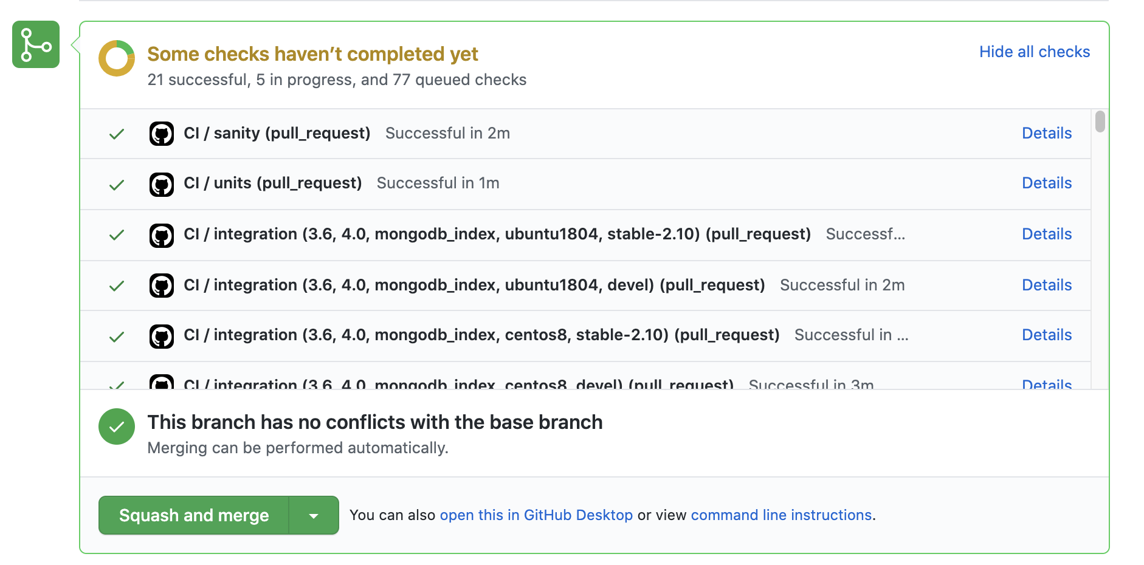
<$Scr_Ps::0>

<!$Scr_Ps::0>

